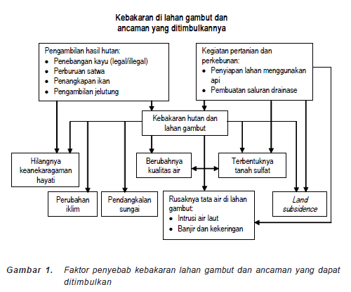

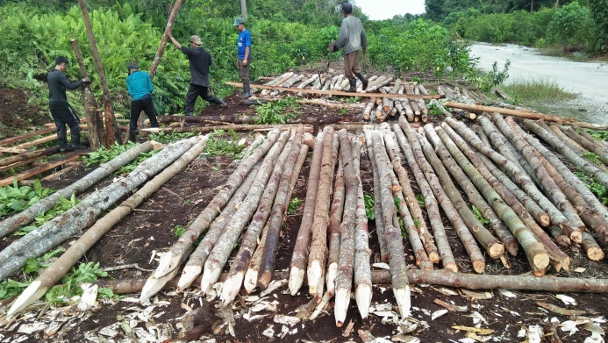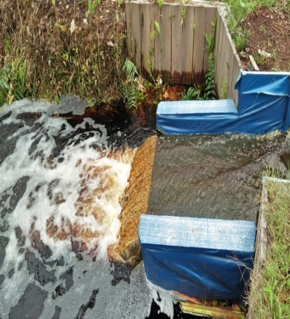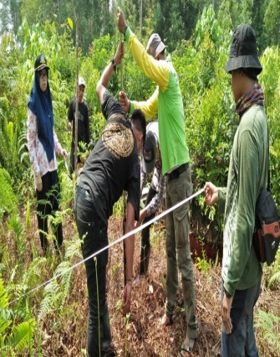
- The building of the stuck canal b. the canal stuck c. the monitor well
Picture 2: The Building of The Stuck Canal and The Monitor Well by Involving the Society Group of Lukun Village

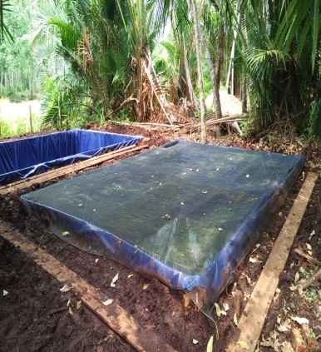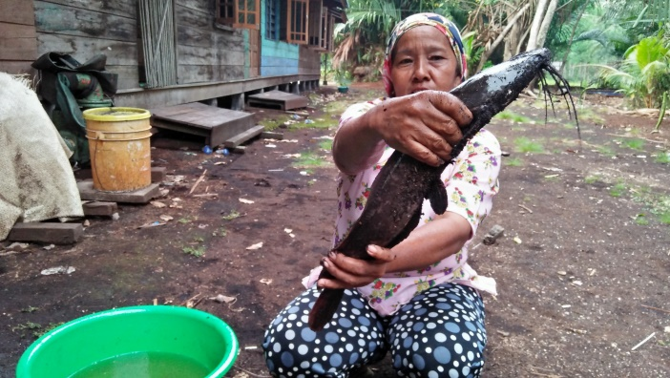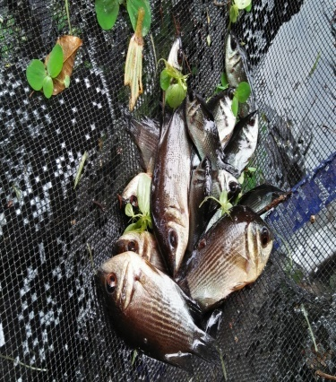
- The fish pond with b. the catfish that is ready c. Tuakang fish
the safeguard net to be harvested
Picture 3: The Economy Empowerment of Society through the fish cultivation of the peat moss swamp

